# Challenge for today.

1. setup terraform in windows local machine.

Open a web browser download a Terraform (version for Window)

Open a downloads folder and select terraform file right click on it extract all files,

Go to task bar search variables (edit the system environment and select environment variable), select the path and edit add new file name end with OK.

Result: go to Command Prompt and type “terraform –version”.

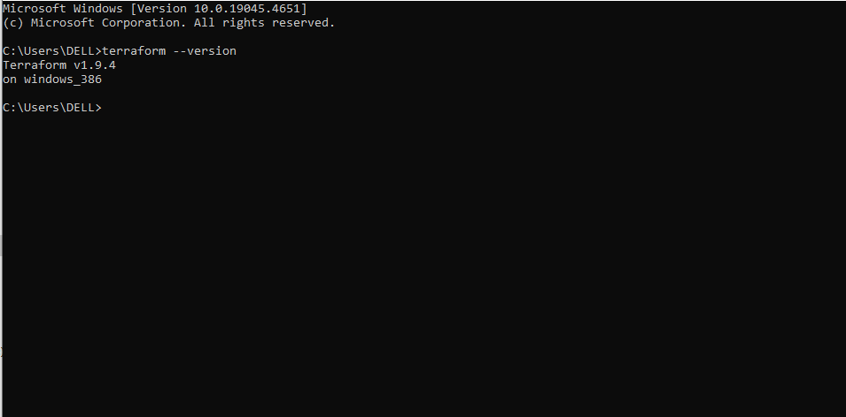

1. write one terraform script to provision an ec2 instance.